Students Results
Write a program that reads number N from the console. After that read N lines with students with their results in format {name} - {firstResult}, {secondResult}, {thirdResult}
Print table on console. Each row must contain:
CAdv - first result, align right with precision of 2
COOP - second result, align right with precision of 2
AdvOOP - third result, align right with precision of 2
Average – average result with precision of 4
Columns must be separated with "|"
Don't forget heading row
Examples
Input | Output
1  Gosho - 3.33333, 4.4444, 5.555 | Name | CAdv| COOP| AdvOOP|Average|  Gosho | 3,33| 4,44| 5,56| 4,4442|
2  Mara - 5, 4, 3  Gosho - 3, 4, 5 | Name | CAdv| COOP| AdvOOP|Average|  Mara | 5,00| 4,00| 3,00| 4,0000|  Gosho | 3,00| 4,00| 5,00| 4,0000|
Hints
It is up to you what type of data structures you will use to solve this problem
First row is easy, but long.
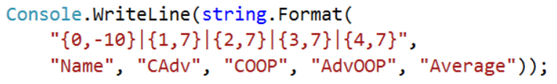
Data rows are something terrible:
